Repository Use Agreement



Repository: https://github.com/marrivbec/gii-is-DP2-C2.033
Members:
- Jesús Villalba Fernández – jesvilfer@alum.us.es
- Juan Ramírez Morales – juarammor2@alum.us.es
- Mario Rivas Becerra – marrivbec1@alum.us.es
- Álvaro Baladrón Caballero – alvbalcab@alum.us.es
- Ángel Manuel Ferrer Álvarez – angferalv@alum.us.es

Date: July 1, 2025

Contents
Permission 3
Signatures 3

Permission
This document certifies that all members of the group have permission to use the project repository during the second examination session. The authorization is granted exclusively for academic purposes within the framework of the course.

Signatures
Group members confirm their commitment to this agreement by signing below:

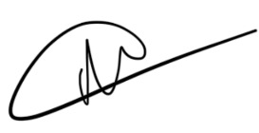
Álvaro Baladrón Caballero Mario Rivas Becerra Jesús Villalba Fernández

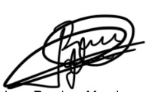
Ángel Manuel Ferrer Álvarez Juan Ramírez Morales

